Eastmorland Community Association Monthly Meeting
April 12, 2022

Meeting will be hosted on Zoom at 7 PM
Join Zoom Meeting
https://us06web.zoom.us/j/8162062676

Board Officers:  Emily Mixon, President  Emily Sprengelmeyer, Vice President  Dan Zimmerman, Treasurer  Jennica Skoug, Secretary | Board Members:  Cindy Colombo  Breanna Illéné  Kathy Soukup  Brian Juchems  Kris Whitman | Alternates:  Patrick Soukup
7:00 Call to order and call for changes to the agenda, introductions using zoom chat feature
7:05 Review and approval of minutes of the March, 2022 Meeting
7:10 Updates of city committees/commissions
(Grant Foster, Alderperson, and Kristen Audet, County Supervisor, if present)
Jacob Wright - next county supervisor (running unopposed). He might come chat in April, and/or for a longer presentation in May.
7:20 Representative from Metro Transit
- Discuss/hear feedback on the Transit network options
7:40 ECA Events & Issues (2022 Events listed here)

- Any articles for May/June newsletter?
    - Board Elections - process and (potentially) results - Jennica can write
    - June 2022 content deadline is April 23rd, 2022

- Parks cleanup, April 23 - discuss point person, logistics, advertising
- Possible new event: Make Music Madison at Lansing Food Forest June 21 (?) https://www.makemusicmadison.org/

- Speeding on Walter
  - Brian: Speeding sign update
  - Yard signs for speeding
    - Jennica: drafts for printing (sponsored signs)
    - Potential for “Twenty is Plenty” signs from city (Grant)
    - Vote on course of action

- Annual Meeting and Board Elections
  - May 7, 1-2pm at Lansing Food Forest (after Eastmorland Outdoor Market).
  - How will we advertise meeting/elections? Point person?
  - Notes from March Meeting:
    - Online ballot to be posted one week prior to May 7
    - Ballot open through end of meeting on May 7, so people can vote in person at the meeting. Ballot will close at end of meeting.
    - For those without computer, others with mobile devices can be present at meeting to assist them with voting.
    - Rain plan = online meeting
  - Five director positions are up for re-election:
    - Emily Mixon
    - Dan Zimmerman
    - Kathy Soukup
    - Brian Juchems
    - Breanna Illene
    - Emily Sprengelmeyer (leaving the board due to a move!)
  - Two alternate positions:
    - Patrick Soukup
    - open position

- Snow Shoveling Assistance - revisit

7:55 Neighbor Announcements

Tunes on the Triangle (Staci Marrese-Wheeler + Others)
Would love to have ECA, El Jardin Infantil, Madison Shakespeare, WI Food Forests and Ethical Trading Co. involved in this neighborhood event. It has been a lovely celebration of community and the schools in past years! A live music tent, pie auction and sale, food trucks, kid’s activities, a pop-up school supply stand have all been part of it in the past. We had around 500 people participate in 2019. We would really like it to have a block party feel to it and your involvement would only make it better!

Please find the Zoom link to our initial planning meeting on April 28th, below. You are all welcome to attend. If you cannot make that meeting, but want to talk more about this event just let me know. Date TBD in September once we know when the Schenk Elementary back-to-school night is so that we can coordinate with them.

Starkweather Drive Prairie Planting (from Maddie Dumas at Madison Engineering) (see photo below agenda for map of planted area)
--Last fall, we decided not to sow seed as the terrace was covered in fall leaves. Instead we took our seed mix and artificially stratified it this winter. We sowed the mix on site this past Friday 3/25. Please see the attachment for the list of what we sowed. With the exception of some of the grasses, all seed was collected on Engineering land! (Seed list here)

--Areas sowed include all the terraces from right next to the driveway at 3401 Hargrove St, up to Dawes. We didn’t sow seed in the small triangle of soil by the new bridge crossing at the Hargrove end. We also skipped sowing the “duck crossing” area near 3401 Dawes St.

--Observed growing in the terrace already is plenty of yellow rocket, a common broadleaf weed. Like most mustards, it’s a biennial. Frank Hassler also noted Kentucky blue grass growing in the area last fall. We will have weed competition. In the first year of a prairie planting it is crucial that it be mowed. This might seem counterintuitive—after all, we don’t want to mow up our prairie plants! Fortunately our native prairie species will take a longer time to germinate and establish than weeds, so when we mow, we are lopping the heads off annual weeds and effectively stopping their reproduction, as well as stressing and/or preventing perennial and biennial weeds from setting seed. Our chances of success at establishing this planting are very low if we don’t mow this first year. Sometimes we may also want to mow into year two. As such, we are looking for volunteers to mow the prairie planting, particularly this growing season! Please reach out if you are willing to mow (MDumas2@cityofmadison.com). Based on the kind of mower you have, we may need to mow more frequently than is typical, as a traditional home lawn mower usually doesn’t have a setting higher than 4” or so (we’d ideally like a setting at about 6”). We can work with a lower mow setting if we mow more frequently.

--If anyone has native plants they would like to donate, that would be great! Let me know what species and what you’re thinking. We may wish to install these in fall or spring 2023 so we can mow without fear of taking out a faster-growing more established plant.

Mowing will comprise most of the management for this year, but it will also be helpful to have eyes on the site. We may choose to pursue other management options as needed. I’ll be keeping an eye on the planting as well of course!

Thanks everyone for your interest in helping out. This project is happening solely due to the interest and assistance we were offered by volunteers. As I said before, we don’t have a budget for plants, seed or maintenance here. This is truly a neighborhood effort.

8:05 Agenda items for May Meeting. Outdoor meeting in June?
8:10 Adjourn

NOTES

Starkweather Dr Prairie Map! (seed mix list here)
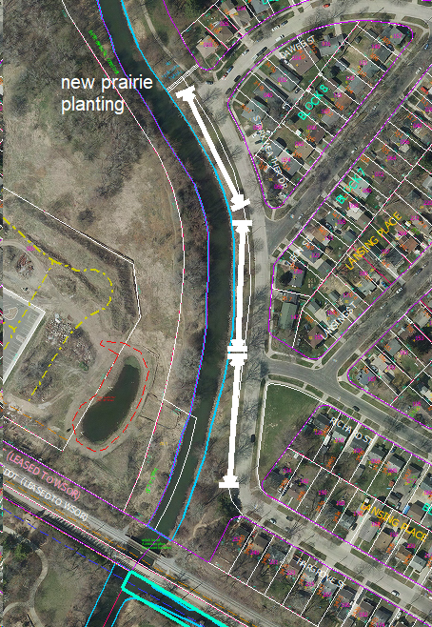

Attendance, Agenda, Minutes

8:00 Agenda items for May 2022
- Board Elections

